Air Force Thunderbirds commander removed over loss of confidence

By [COREY DICKSTEIN](https://www.stripes.com/reporters/2.2149?author=Corey_Dickstein) | STARS AND STRIPES | Published: November 29, 2017

*U.S. Air Force Lt. Col. Jason Heard, commander/leader of the Thunderbirds Air Demonstration Squadron.*

[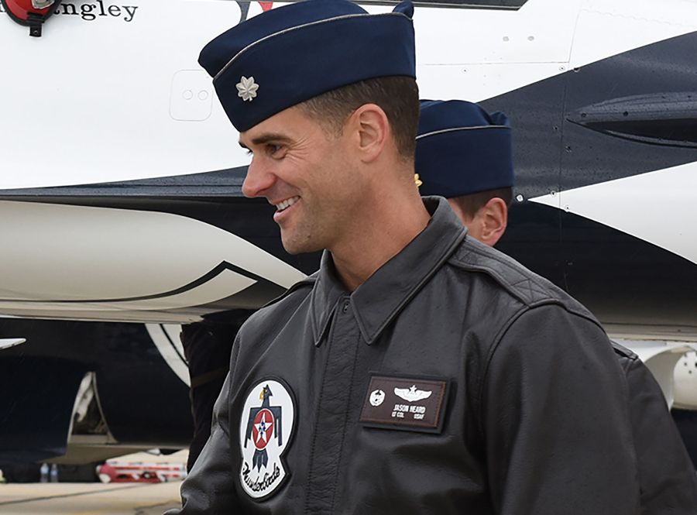](https://www.stripes.com/polopoly_fs/1.500036.1511985538!/image/image.jpg_gen/derivatives/landscape_900/image.jpg)WASHINGTON — The Air Force has removed the commander of the high-profile Thunderbirds demonstration team due to a loss of confidence in his abilities to lead the touring squadron of F-16 fighter jets, the service announced Wednesday in a statement.

Lt. Col. Jason Heard was dismissed Nov. 20 as commander of the Thunderbirds – officially known as the U.S. Air Force Air Demonstration Squadron – and pilot of the team’s No. 1 jet. Brig. Gen. Jeannie Leavitt, commander of the service’s 57th Wing, dismissed Heard, citing a loss of confidence in his “leadership and risk management style.”

"This was an incredibly difficult decision to make, but one that is ultimately in the best interests of the Thunderbird team,” she said in the statement. “I am personally grateful for Jason's dedication to the 2017 season.”

On Nov. 4, the Thunderbirds, based at Nellis Air Force Base in Nevada, completed their 2017 season, which included more than 70 air shows. The team pulled out of a scheduled air show in June following the crash of one of the unit’s jets during training prior to a two-day performance at the Dayton Air Show in Ohio.

Air Force investigation determined the June 23 crash was avoidable. The F-16 was traveling too fast and had insufficient stopping distance as it landed on a rain-soaked runway before it overturned, destroying the $29 million aircraft, according to the Air Force Accident Investigation Board’s report released earlier this month.

The board found the pilot failed to follow proper braking procedures and his vision was impaired by rainwater on the cockpit’s canopy. The pilot suffered minor injuries.

However, Tech. Sgt. Christopher Boitz, a spokesman for the Thunderbirds, said the crash was not the reason Leavitt dismissed Heard.

He said Leavitt had concerns that Heard’s leadership style was resulting in unnecessary risk within the Thunderbirds’ demonstrations, “which eroded the team dynamic.”

*Thunderbird jet overturned in Dayton, OH on June 23, 2017, after landing during a practice ahead of an airshow.*

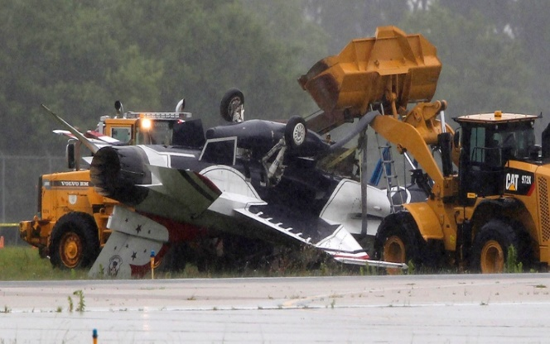“We are on the road together more than 200 days per year, executing flying operations with absolutely no margin for error,” Boitz said. “As a result, absolute trust and teamwork in both our professional and personal dynamics are foundational to our mission.”

Leavitt determined the team was better off with new leadership as it begins preparing for its 2018 schedule, according to the Air Force.

Lt. Col. Kevin Walsh, who has served as the Thunderbird’s operations officer since 2016, was temporarily named commander of the unit until the Air Force selects a new permanent

Thunderbird officers typically serve two-year assignments with the popular demonstration team, according to the Air Force. Heard had taken command of the unit in January.

Heard commissioned into the Air Force in 1999 after graduating from the University of Texas at Austin, according to his Air Force biography. He served as an F-15 weapons systems operator before becoming a pilot. Heard had previously served as commander of an F-15 squadron and had logged more than 3,000 flight hours including nearly 800 combat flight hours over Iraq, Afghanistan and Libya. His awards included the Distinguished Flying Cross.

In an Air Force profile of Heard published on the Thunderbirds’ website, when he took command of the squadron, the pilot described the unit as an inspiration to many people.

“To me, service as a Thunderbird is both an honor and a privilege,” Heard said. “It requires significant sacrifice rewarded by the trust our fellow airmen place in us to represent them to the public. I promise to provide adaptive leadership, maintain the standards and fly a safe show.”

The Thunderbirds 2018 schedule is set to begin Feb. 18 with a flyover at NASCAR’s Daytona 500 in Florida. The squadron’s first air show for the year is set for March 10 and March 11 at Luke Air Force Base in Arizona.

# **Thunderbirds commander was fired after grabbing neck of another pilot in bar argument**

By: Stephen Losey | Air Force Times | Published: November 20, 2018

#### The Thunderbirds perform a flyover at FedEx Field in Landover, Maryland, before the start of the Washington Redskins home opener Sept. 10, 2017. Thunderbirds pilots thought their former commander, Lt. Col. Jason Heard, carried out this flyover at a far lower altitude than was safe -- one in a series of instances when pilots felt Heard violated flying regulations. (SrA Delano Scott/Air Force)

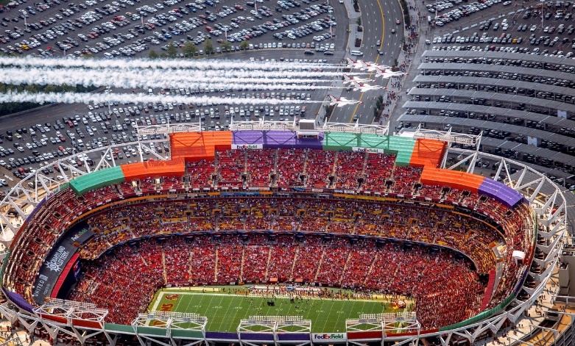Months of tension over former Thunderbirds commander Lt. Col. Jason Heard’s perceived risk-taking leadership style boiled over in a “physical altercation” in a Maryland bar last September, in which Heard put his hands on another Thunderbird pilot’s neck.

Heard was relieved of command last November after a commander-directed investigation found he “did exhibit aggressive physical contact towards his subordinate," an unnamed member of the U.S. Air Force Air Demonstration Squadron, on Sept. 11, 2017, at an Irish pub in National Harbor, Maryland.

The report, obtained by Air Force Times via the Freedom of Information Act, said that on that evening, the unnamed pilot was “agitated” by how Heard was leading Thunderbirds flights, and felt he was not following the “rules," or flying regulations. Multiple witnesses told investigators that they were concerned about the relationship between Heard and that pilot, and that the pilot told several teammates he thought Heard “was going to kill him” while flying.

The “tense relationship” erupted in the bar last September, the day after the Thunderbirds conducted a flyover for the Washington Redskins home opener at FedEx Field in Landover Maryland.

Seven witnesses observed the altercation, the report said, and “witness testimony was consistent that Lt. Col. Heard placed his hands around [the unnamed pilot’s] neck.” Witnesses told investigators that both Heard and the other pilot had consumed alcohol that evening. One of the witnesses, who was closest to the two, intervened and broke it up, the report said.

That pilot wasn’t the only one who felt Heard was breaking the rules. Multiple witnesses testified that Heard “compromised safety and violated Air Force flying regulations and FAA regulations,” the report said.

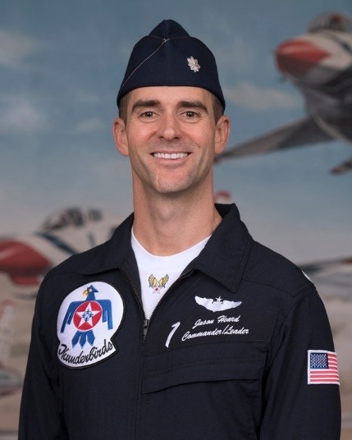 *Lt. Col. Jason Heard was relieved of command of the Thunderbirds on Nov. 20. (Air Force)*

Witnesses testified that when Heard led the Thunderbirds delta formation flyover above the Redskins game Sept. 10, 2017, they were flying at an altitude well below the minimum for a populated area, the report said.

Heard also intentionally took a diamond formation of Thunderbirds supersonic while en route to the Royal International Air Tattoo, the world’s largest military air show, in July 2017, witnesses told investigators. And in a third incident of perceived unsafe behavior, witnesses told investigators Heard attempted a loop on takeoff at an airshow in Boise, Idaho, even though the weather conditions were too overcast.

Multiple witnesses also told investigators that they perceived Heard’s leadership style to be “hostile,” the report said.

The report concluded that as commander and leader of the Thunderbirds, Heard was “charged to maintain good order and discipline in the squadron he commands. By exhibiting aggressive physical contact toward his subordinate, [redacted], he demonstrated a lack of judgement [sic] and ability to effectively command his unit.”

Heard took command of the squadron Jan. 6, 2017, and was relieved at the conclusion of the season Nov. 20, 2017, by Brig. Gen. Jeannie Leavitt, former commander of the 57th Wing at Nellis Air Force Base in Nevada.

“This was an incredibly difficult decision to make, but one that is ultimately in the best interests of the Thunderbird team,” Leavitt said at the time. “I am personally grateful for Jason’s dedication to the 2017 season.”

The Air Force said in a release last November that “Leavitt lost confidence in his leadership and risk management style [and] determined that new leadership was necessary to ensure the highest levels of pride, precision and professionalism within the team.”

Thunderbirds spokesman Maj. Ray Geoffroy went on to say last November that “concerns arose that his approach to leading the team was resulting in increased risk within the demonstration, which eroded the team dynamic. ... We are on the road together more than 200 days per year, executing flying operations with absolutely no margin for error. As a result, absolute trust and teamwork in both our professional and personal dynamics are foundational to our mission.”

When asked for comment Tuesday, Geoffroy referred to last year’s statements. It is unclear what Heard’s current assignment is.