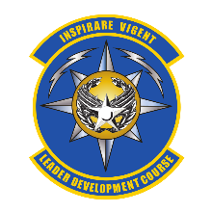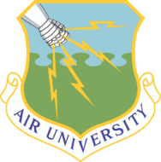**Leader Development Course**

**for**

**Squadron Command**

**CSAF, Gen David Goldfein:** “The squadron is the beating heart of the United States Air Force; our most essential team. We succeed or fail in our missions at the squadron-level because that is where we develop, train, and build Airmen.”

**Mission:** Inspire and Equip Air and Space Professionals to Thrive in Command

**Vision:** Increase Air and Space Force lethality by strengthening squadron leadership and culture

***Increase self-awareness and emotional intelligence to provide purposeful leadership.***

***Develop interpersonal skills to foster esprit de corps.***

***Build a unit culture conducive to achieving verifiable mission success.***

**Course guidance:**

* AFI 1-2, Commander’s Responsibilities, May 2014
* Squadron Revitalization Implementation Plan, SECAF/CSAF/CMSAF, June 2018
* Improving Air Force Squadrons,. Recommendations for Vitality, Gen Davis, Jan 2018

**Summary of Learning Objectives:**

* Understand the fundamental responsibilities of command
* Increase self-awareness to improve emotional intelligence and time/energy management
* Improve communication, feedback, and coaching skills
* Enhance decision making through values alignment and cognitive diversity
* Inspire a trusting climate to improve unit performance, resiliency, and retention
* Develop a deliberate plan to connect Airmen and families to higher purpose
* Cultivate a growth mindset that leverages calculated risk and productive mistakes

**Course details:**

Content: Leadership course focused on squadron-level human-domain competency

Format: 8-day (67 contact-hour) seminar-based, in-residence course taught at Maxwell

Cadre: Graduated squadron commanders and civilian academic experts. Augmented by JAG School, First Sergeant Academy, Chief’s Leadership Course, Chaplain’s College and Air Force Negotiation Center instructors

Mentors: Retired general officers and current wing command teams

Eligibility: Total Force. Officers with 9-16 years commissioned service or GS-13-equivalent civilians. Senior raters select candidates. SOS complete (officers)

Timing: 6 mos – 3 yrs prior to 1st command – allows time for personal growth

Throughput: 16 classes, 990 students per year. Quotas allocated via MAJCOM/CCMD staff

**Graduate Feedback:**

* 98% 4 or 5 star rating (1,100+ graduates); “Life Changing!”
* “I leave here knowing I can confidently lead with my heart
* “I now believe I can complete command with my family intact… I don’t know   
  if that would have been the case before this course”

[EakerCenter.LDCSC@us.af.mil](mailto:EakerCenter.LDCSC@us.af.mil) Bit.ly/leaderdevelopmentcourse