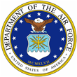 | Mr. Jason Womack  s | 

UNITED STATES AIR FORCE

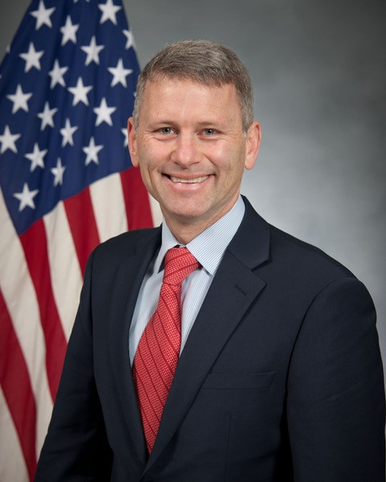
Duty Title: Instructor of Leadership Studies

Hometown: Ojai, California

Meyers-Briggs: ENTJ

Primary Voice: Pioneer & Creative

Areas of Specialization: Leadership Development, Personal Productivity, Executive Coaching

Quote: “Ask for help…sooner.”

EDUCATION
2003 Master of Arts, Psychology, University of Santa Monica
1996 Master of Education, Teaching and Learning, University of California
1995 BA US History, University of California
1995 BA Spanish Literature, University of California

LEADERSHIP, TEACHING, AND SERVICE EXPERIENCES
2019 Instructor, Leadership Studies, Leader Development Course, AU
2013-2019 Adjunct Faculty, ACSC, AU
2012-2018 Expert Speaker/Coach, The Get Momentum Leadership Academy
2007-2018 Author/Executive Coach, The Womack Company
2000-2006 Executive Coach/Senior Facilitator, Getting Things Done
1996-2000 Mentor/Master Teacher, Nordhoff High School, Ojai California

KEY PUBLICATIONS
- Get Momentum: How to Start When You’re Stuck (John Wiley & Sons, 2016)
- Your Best Just Got Better: Work Smarter, Think Bigger, Achieve More (John Wiley & Sons, 2012)
- The Promise Doctrine (Womack & Womack, 2010)
- Microsoft ® Outlook ® I Didn’t Know It Could Do That (Womack & Womack, 2008)

