|  |  |  |
| --- | --- | --- |
| http://www.af.mil/DesktopModules/ArticleCS/Templates/Air%20Force%20-%20Biography/bio_seal.gif | Lt Col Jonathon Byrnes  “JB” | http://www.af.mil/DesktopModules/ArticleCS/Templates/Air%20Force%20-%20Biography/bio_flag_wings.gif |
| ***U N I T E D   S T A T E S   A I R   F O R C E*** | | |

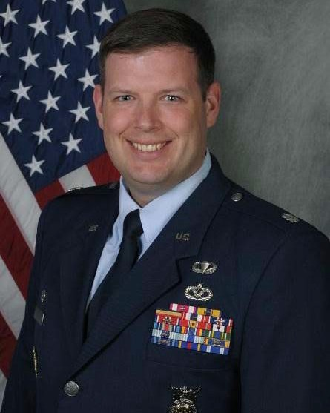

Duty Title: AU Fellow, CSAF Leadership Course

Hometown: Springfield, Massachusetts

Myers-Briggs: ENFP Primary Voice: Creative

Core AFSC: 32E (Civil Engineer)

Biggest Lesson From Command: Delegate everything that does not require your action—you get more diversity of thought, empower those that work for you to act decisively, and free up your calendar to focus on those items that REQUIRE your focus.

**EDUCATION**

1999 Bachelor of Science in Civil Engineering, United States Air Force Academy, Colorado Springs, CO

2002 Master of Science in Construction, Arizona State University, Tempe, AZ

2004 Squadron Officer School, Maxwell AFB, AL

2011 Air Command and Staff College, by correspondence

2017 Joint Combined Warfighting School, National Defense University, NSA Hampton Roads, VA

**COMMAND ASSIGNMENTS**

1. Sep 2011 – Apr 2012, Commander, 405th Expeditionary Civil Engineer Squadron, RAFO Thumrait, Oman

2. May 2014 – Jun 2017, Commander, 48th Civil Engineer Squadron, RAF Lakenheath, England