 | Mr. Ian Carleton Empey | 

UNITED STATES AIR FORCE

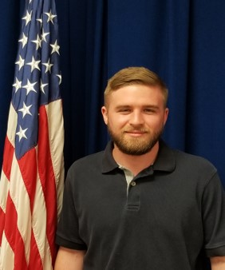
Duty Title: Technology Integration Support

Hometown: Salt Lake City, Utah

Myers-Briggs: ENFP-A

Primary Voice: Campaigner

Career Specialty: Information Technology

Hobbies: Fitness, Technology, Outdoors

EDUCATION
2012 AS - General Education, Troy State University, Montgomery, AL

EXPERIENCE
- May 2017 - March 2019 IT Help Desk Administrator, Caddell Construction Co, Montgomery, AL
- March 2015 - May 2017 Technology Support Specialist, Shaw Technologies, Montgomery, AL

