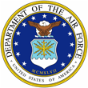 | John M. Hinck, PhD  s | 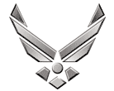

UNITED STATES AIR FORCE

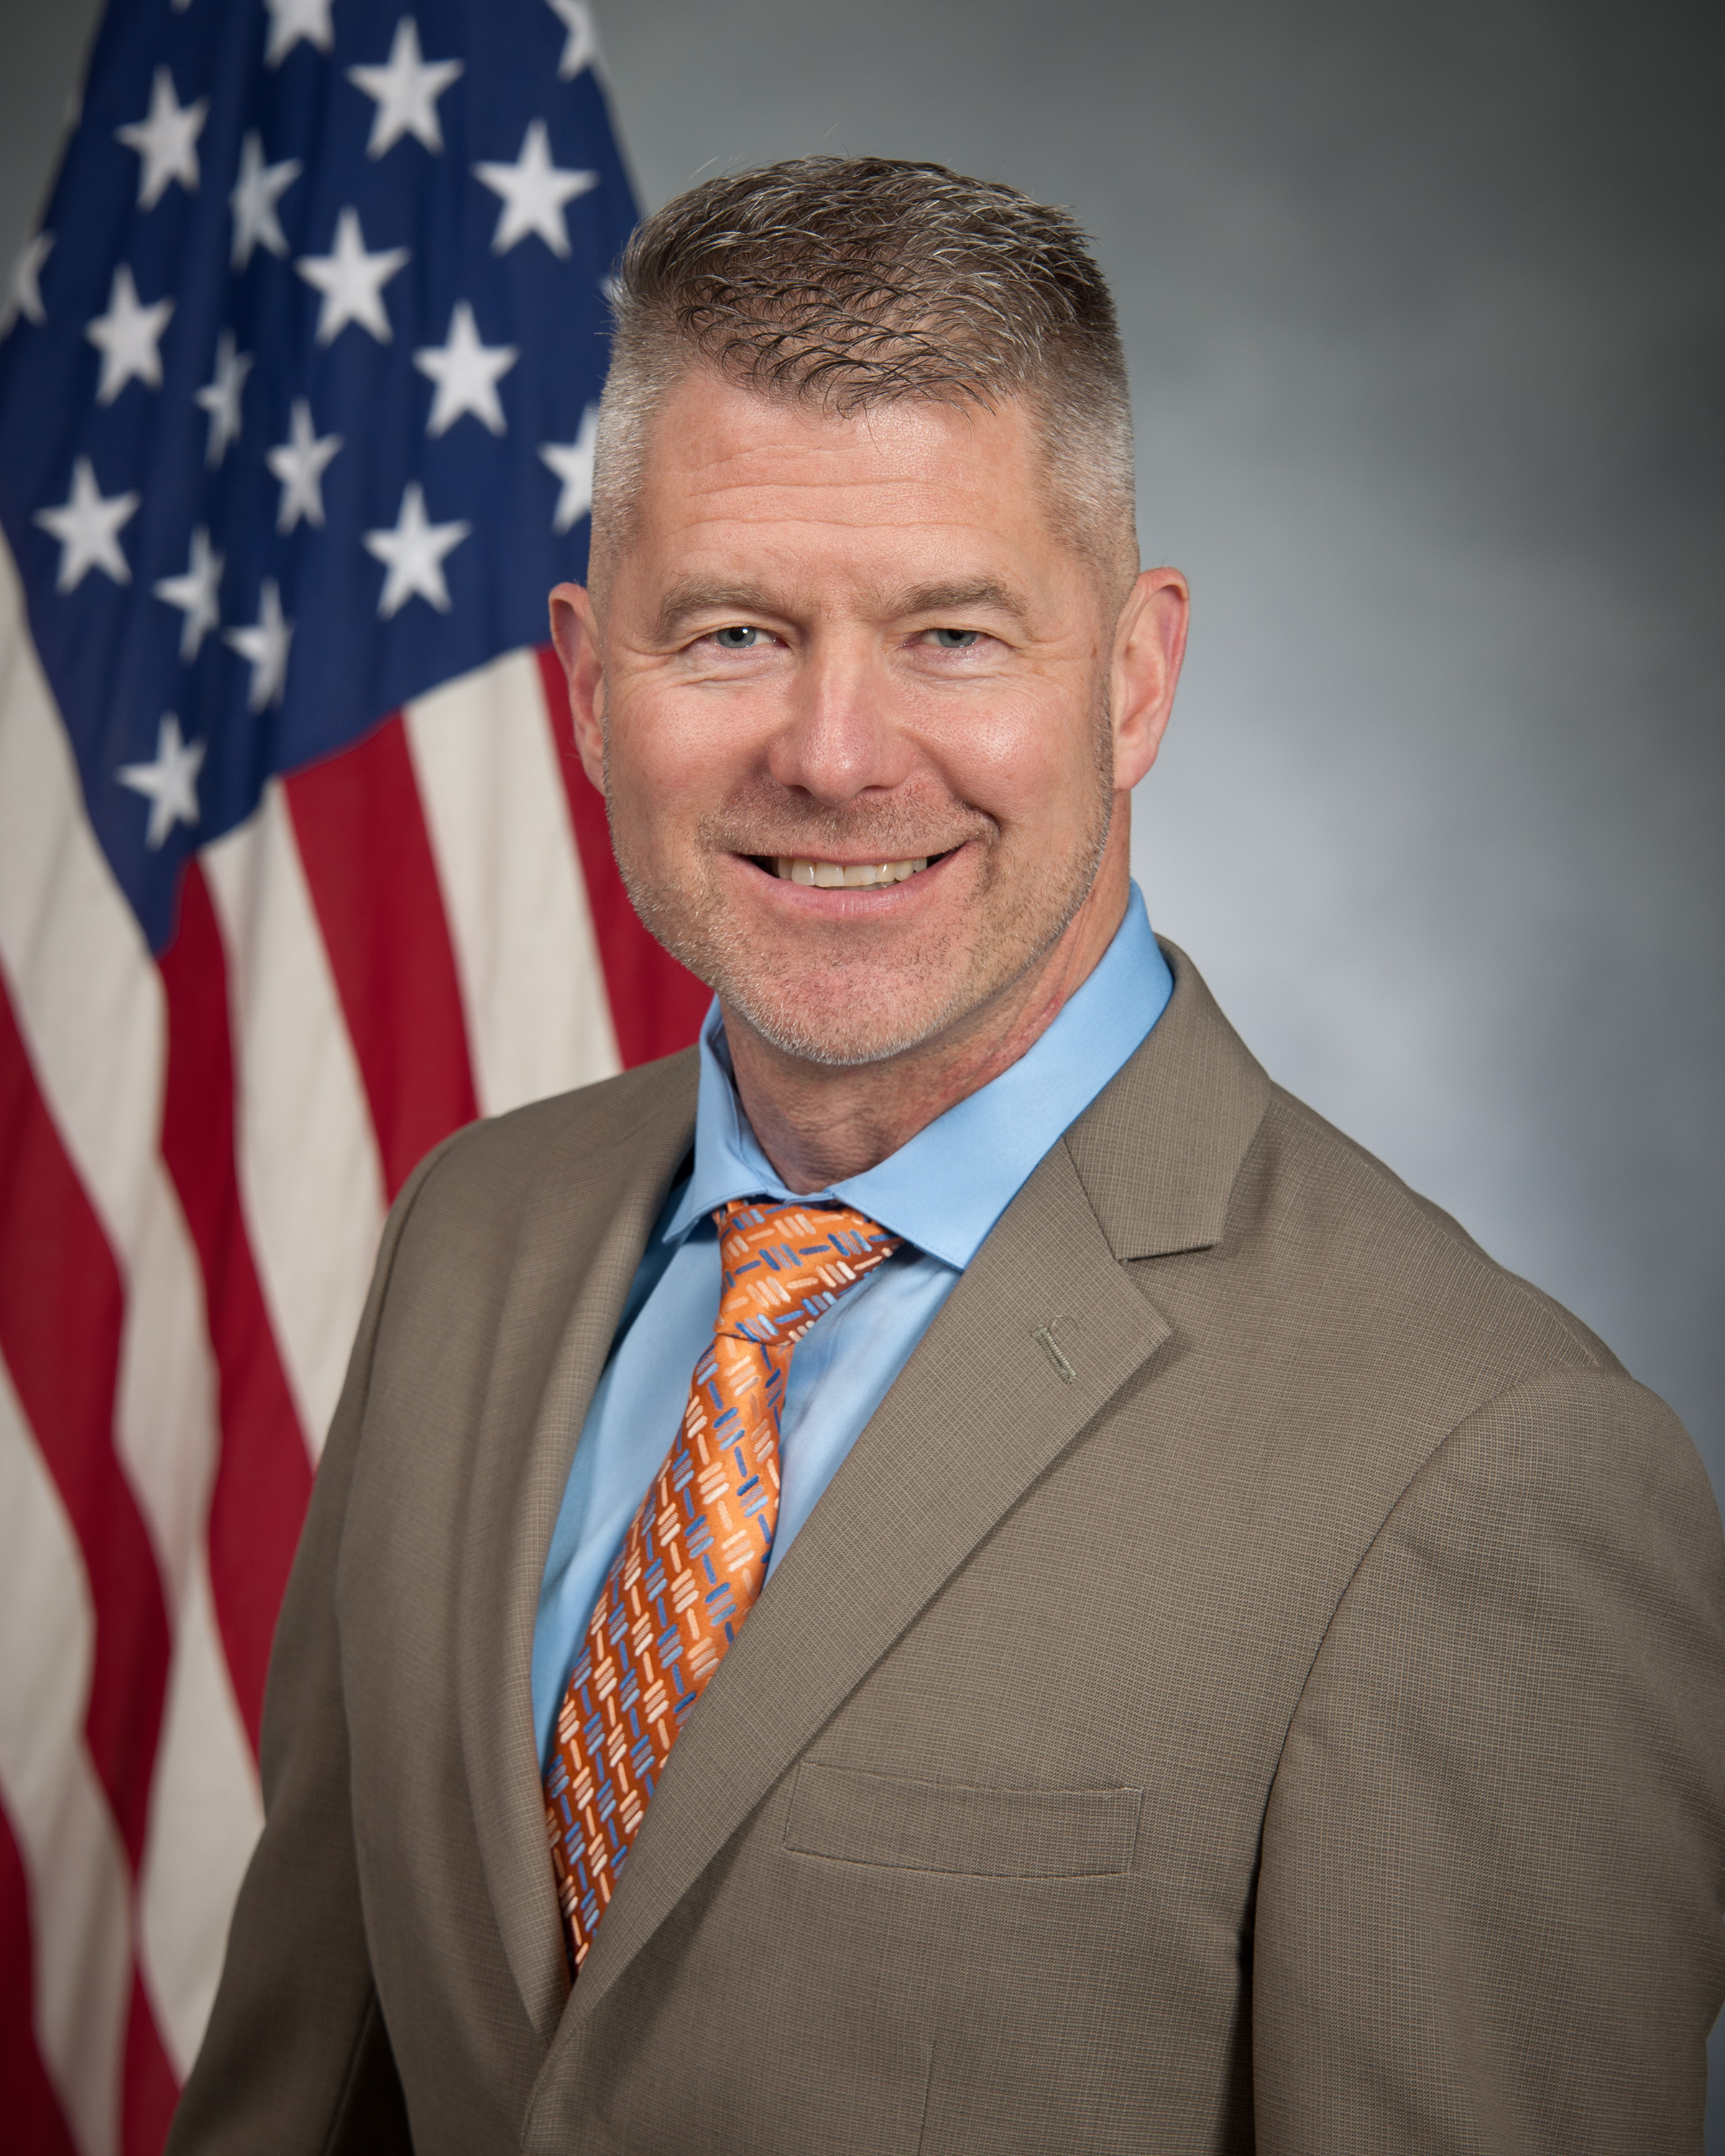
Duty Title: Assistant Professor of Leadership, 2018-2020

Home: Fresno and San Diego, California

Specializations: Leadership Development, Board Certified Executive Leadership Coach and Personal Life Coach

Former Army Colonel and Apache Longbow Pilot

Quotes: “Attack!” “Work hard! Play safe! Rest long!”

EDUCATION
2018 Doctor of Philosophy, Leadership Studies, University of San Diego
2017 Moller-Burns Learn to Lead Program, University of Cambridge, England
2003 Master of Science, Administration, Central Michigan University
2003 Master of Military Art and Science, US Army Command & General Staff College
1991 BA, Aviation Mgt; Distinguished Military Graduate, California State Univ, Fresno

LEADERSHIP and SCHOLARSHIP
2019 Air University Civilian of the Year (Category IV/Non-Supervisory)
2019 Eaker Center’s Team of the Year (Faculty Development Team)
2019-2020 Leadership Montgomery, Legacy Class XXXVI
2019-2020 USAF Coaching Culture Working Group
2019 “Leadership Development of Military Officers as Leadership Coaches” and “Measuring Impact of the Leader Development Course for Squadron Command”
in the Proceedings of the 3rd Global Conference on Education and Research
2017 “Designing an Organizational Leadership Development Program: A Case Study Approach” in Journal of Nonprofit Education and Leadership, 7(4), pp. 268-286
2015 Strength & Honor: 64 Stories of Leadership, Character, and Values, Book Press
2015-2020 Faculty, Hansen Summer Institute on Leadership & International Cooperation
2011-2013 Commander, US Army Recruiting Battalion, Fort Snelling/Minneapolis
2010-2011 Aide-de-Camp, Commanding General, US Army Forces Command, Atlanta
2009-2010 Commander, Task Force ODIN-Afghanistan, Bagram, Afghanistan
2008-2009 Commander, 3rd Battalion-214th Aviation Regiment, Fort Hood, Texas

