|  |  |  |
| --- | --- | --- |
| http://www.af.mil/DesktopModules/ArticleCS/Templates/Air%20Force%20-%20Biography/bio_seal.gif | Lt Col Ryan Natalini  “Nat” | http://www.af.mil/DesktopModules/ArticleCS/Templates/Air%20Force%20-%20Biography/bio_flag_wings.gif |
| ***U N I T E D   S T A T E S   A I R   F O R C E*** | | |

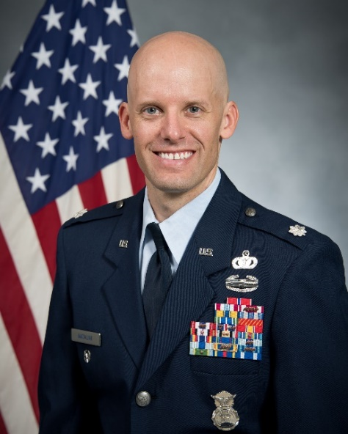

Duty Title: Instructor, CSAF Leader Development Course

Hometown: Plymouth, MI

Myers-Briggs: ENFP Primary Voice: Pioneer / Connector

Core AFSC: 31P (Security Forces)

Biggest Lesson(s) From Command:

Keep your Balance

Correct decisions and behavior, not people

Ask for help… everywhere

Command should not be lonely

**EDUCATION**

2003 Bachelor of Arts degree in Criminal Justice, Michigan State University

2003 Air and Space Basic Course, Maxwell AFB, Ala

2008 Squadron Officer School, Maxwell AFB, Ala

2011 Master of Arts degree in National Security Studies, American Military University

2012 Air Command and Staff College (by correspondence)

2015 Air Command and Staff College, Maxwell AFB, Ala

**COMMAND ASSIGNMENTS**

1. Jun 2015-Jun 2016, 386th Expeditionary Security Forces Squadron, Ali al Salem Air Base, Kuwait

2. Jun 2016-Jun 2018, 2d Security Forces Squadron, Barksdale Air Force Base, Louisiana