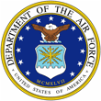 | Ms. Michelle Alexander Harris  s | 

UNITED STATES AIR FORCE

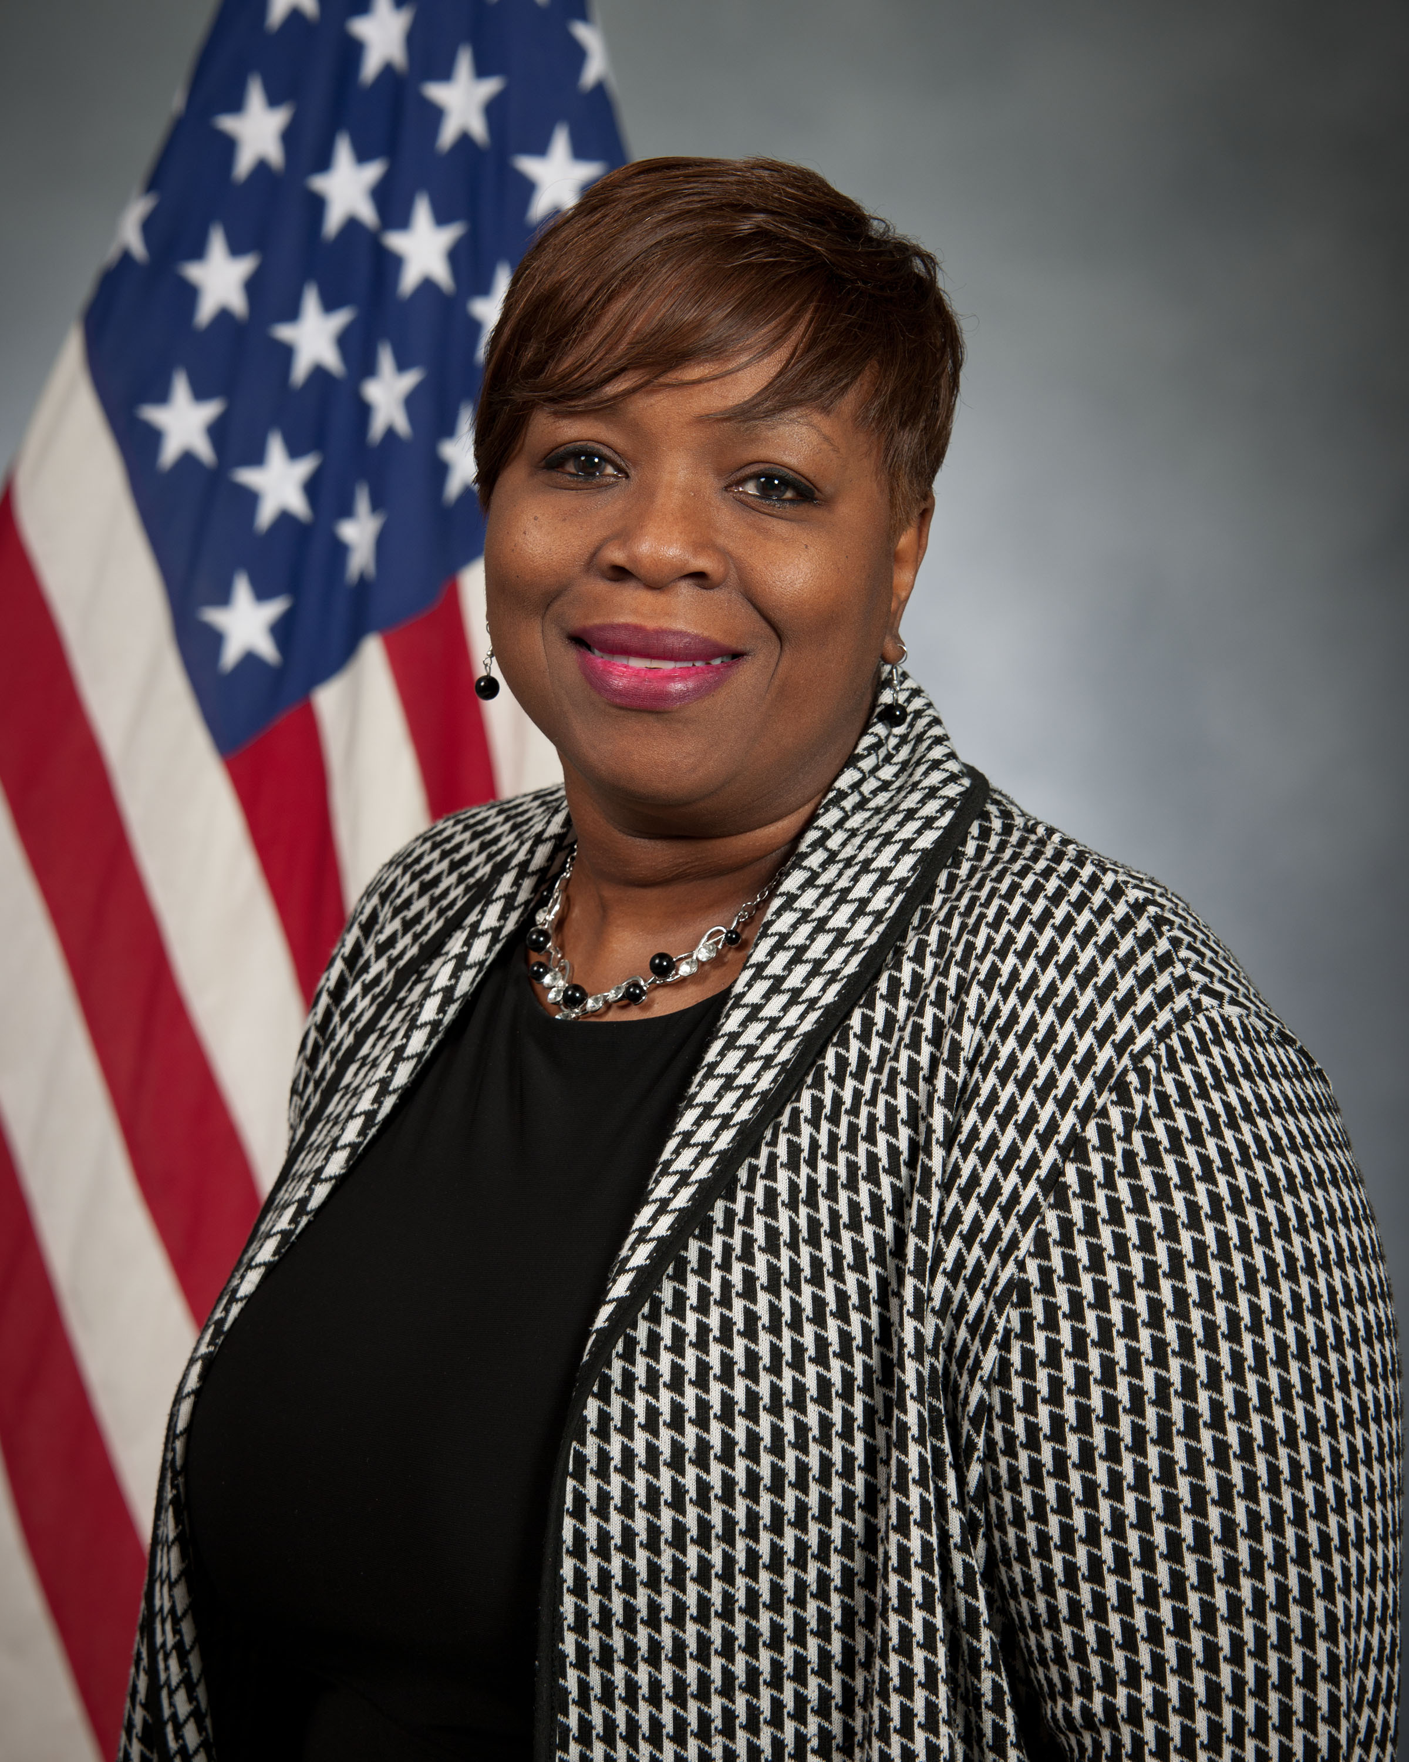
Duty Title: Education Accreditation Support, Student Manager, Ira C. Eaker Center for Professional Development

Hometown: Montgomery, AL

Myers-Briggs: ESFP

Primary Voice: Nurturer

Hobbies: Music, Reading, Movies and Enjoy Quality Time with Family.

EDUCATION
1985 Business Administration, AUM, Montgomery, AL
2000 Associate of Business, Coastal Training Institute, Montgomery, AL

EXPERIENCE
1. February 2014 – November 2017, Fortis College, Career Service Advisor, Montgomery, AL
2. August 2005 – October 2010, State of Alabama Deputy Director of Service Division, Administrant Support Assistant III, Montgomery, AL
3. January 2003 – August 2005, State of Alabama Finance Department, Comptroller Division, Administrative Support Assistant III, Montgomery, AL
4. January 1995 – June 2003, State Finance Department Printing & Publications Department, Administrative Support Assistant II/Office Manager, Montgomery, AL

