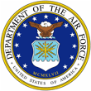 | Mrs. Alison (Ali) Stokley | 

UNITED STATES AIR FORCE

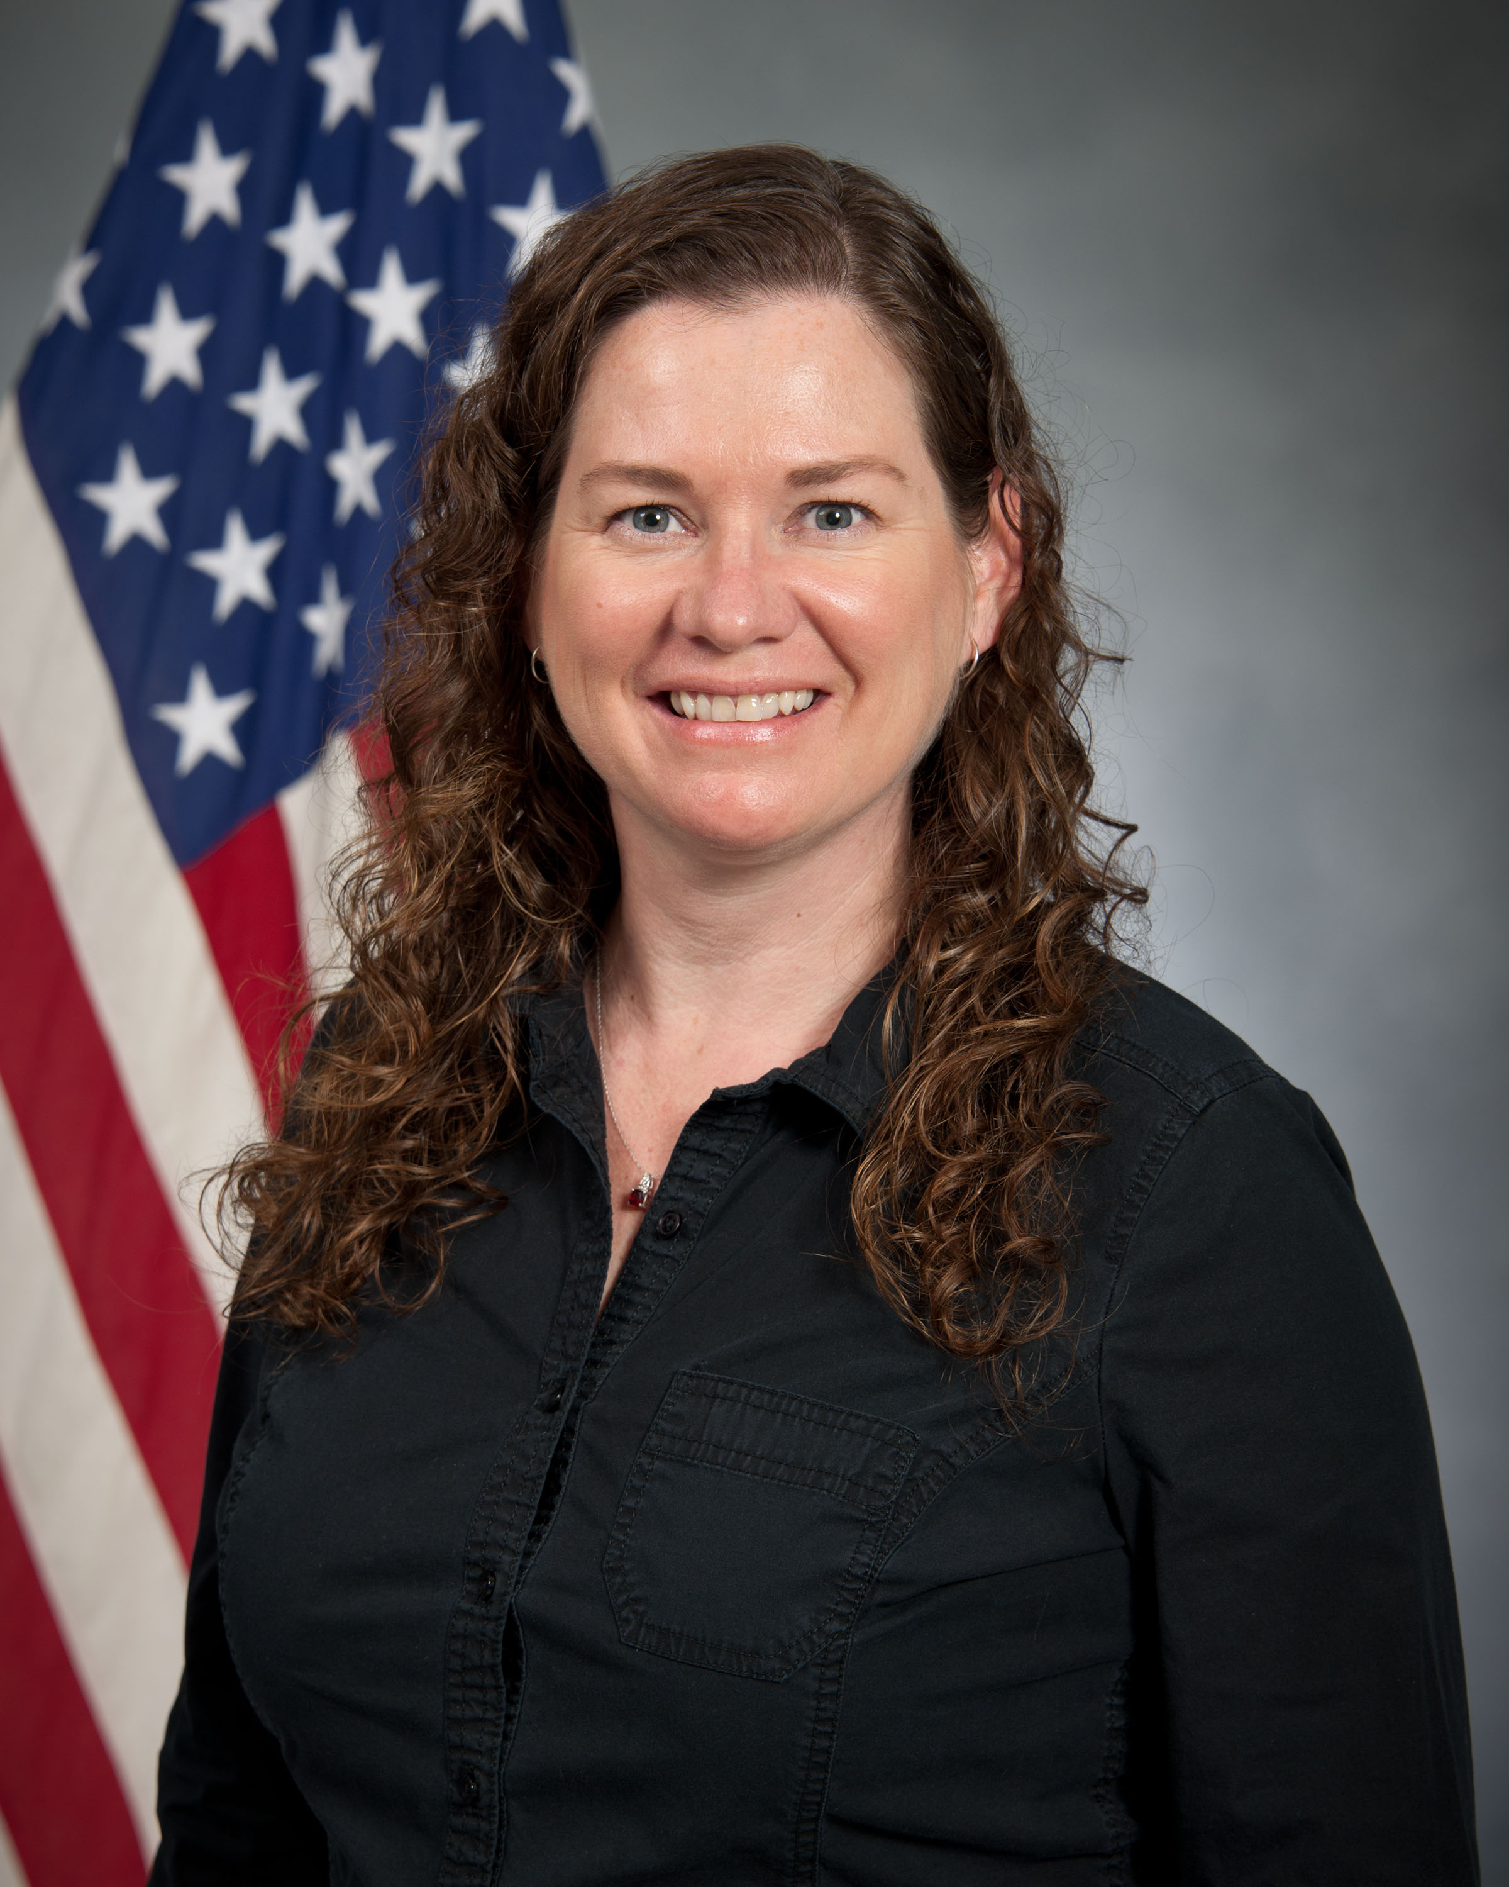
Duty Title: Education Accreditation Support, Student Manager

Hometown: Alexandria, Louisiana

Myers-Briggs: ISTJ

Primary Voice: Guardian & Nurturer

Hobbies: Spending time with family, gardening, cooking, and music.

EDUCATION
2002 Associate of Arts in Criminal Justice, Okaloosa Walton Community College, Niceville, Florida.
2003 Bachelors of Arts in Criminal Justice/Forensic Studies, University of West Florida, Pensacola, Florida.
2007 Master of Science in Criminal Justice Administration, University of West Florida, Pensacola, Florida.

EXPERIENCE
- May 2017-Apr 2018, Human Resources Manager, Logistical Compliance Coordinator, and OSHA Safety Advisor, Southeast Forest Products, Montgomery, Alabama.
- Mar 2014-Apr 2018, Assistant Manager, Coosa Food Mart, Prattville, Alabama.
- Jan 2004-Oct 2005, Graduate Assistant, College of Professional Studies, University of West Florida, Pensacola, Florida.
- Aug 2003-May 2005, Victim Advocate, Okaloosa County Sheriff’s Office, Victim Assistance Center, Shalimar, Florida.
- Oct 2004-Jan 2005, Administrative Assistant, Sexual Assault Interagency Council, Bridgeway Center, Inc., Ft. Walton Beach, Florida.
- Work-Study Student, College of Professional Studies, University of West Florida, Pensacola, Florida.

