|  |  |  |
| --- | --- | --- |
| http://www.af.mil/DesktopModules/ArticleCS/Templates/Air%20Force%20-%20Biography/bio_seal.gif | Lt Col Douglas Freeman  “Doug” | http://www.af.mil/DesktopModules/ArticleCS/Templates/Air%20Force%20-%20Biography/bio_flag_wings.gif |
| ***U N I T E D   S T A T E S   A I R   F O R C E*** | | |

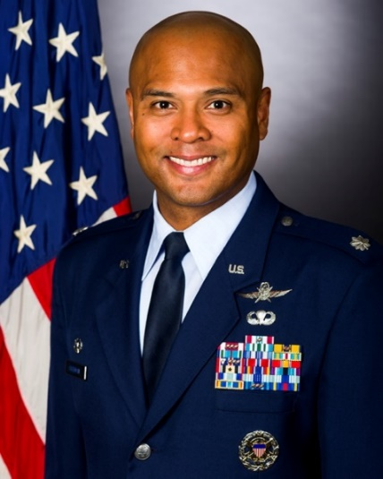

Duty Title: Instructor, CSAF Leadership Development Course

Hometown: Montgomery, Alabama

Myers-Briggs: ENFP Primary Voice: Nurturer

Core AFSC: 17D (Cyberspace Operations)

Biggest Lesson from Command: The diverse and unique backgrounds of the Airmen in your squadron is what makes it great. They all have a story – learn it. Take care of your people and they will go out of their way to take care of you. We have the best trained Airmen in the world – the mission is the easy part.

**EDUCATION**

1998 Bachelor of Science in Management Information Systems, Auburn University, AL

2002 Master of Science in Telecom Management, University of Maryland University College, MD

2004 Squadron Officer School, Maxwell AFB, AL

2011 Air Command and Staff College, Maxwell AFB, AL

2016 Joint Combined Warfighting School, National Defense University, NSA Hampton Roads, VA

**COMMAND ASSIGNMENTS**

1. June 2011 – Jun 2013, Commander, 460th Space Comm Squadron, Det 1, Kapaun Air Station, Germany

2. June 2015 – Jun 2017, Commander, AFOSI Field Support Squadron, Quantico Marine Corps Base, Virginia