|  |  |  |
| --- | --- | --- |
| Description: Seal | Mr. Milton L. Shipman II | Description: Flag |



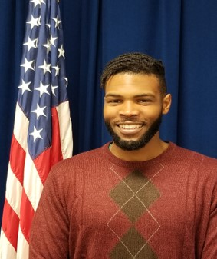

Duty Title: Technology Integration Specialist

Hometown: Clarksville, TN

Myers-Briggs: ESTJ

Primary Voice: Nurturer

Career Specialty: Information Technology and Systems

Hobbies: Fitness & Recording Music

**EDUCATION**

2020 BA – Interdisciplinary Studies – Applied Health Sciences, Social Sciences, and Human Services

2020 – Google IT Professional Certification

2019 – COMPTIA Security + Certification

2018 AS – Computer Information Systems

**EXPERIENCE**

1. March 2019 – Present Technology Integration Specialist, Maxwell Air Force Base, Montgomery, AL
2. November 2018 – February 2019 – Fitness Instructor, Planet Fitness, Montgomery, AL
3. February 2015 – November 2018- System Support Analyst, Guardian Credit Union, Montgomery, AL