|  |  |  |
| --- | --- | --- |
| http://www.af.mil/DesktopModules/ArticleCS/Templates/Air%20Force%20-%20Biography/bio_seal.gif | Lt Col Nathan McClure  “Nate” | http://www.af.mil/DesktopModules/ArticleCS/Templates/Air%20Force%20-%20Biography/bio_flag_wings.gif |
| ***U N I T E D   S T A T E S   A I R   F O R C E*** | | |

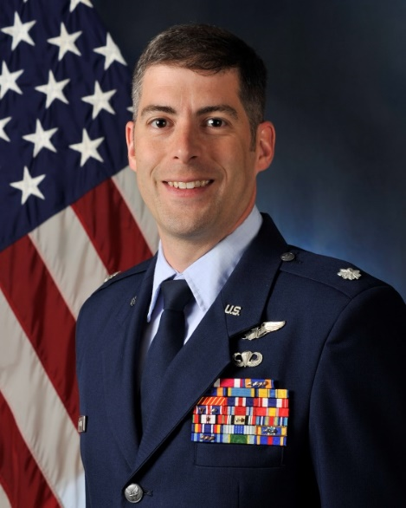

Duty Title: AU Fellow, CSAF Leadership Course

Hometown: Hagerstown, Maryland

Myers-Briggs: ISFP Primary Voice: Nurturer

Core AFSC: 11S (SOF Pilot)

Biggest Lesson From Command: Leading America’s top 1%ers who have chosen to serve their country was one of the most rewarding and challenging experiences in my professional career. You will succeed by taking the time to get to know your people, walking alongside them during tough life circumstances, championing their successes, and leading the squadron with your Triad (CC, Superintendent, 1Sgt).

**EDUCATION**

1999 Bachelor of Science in Engineering Sciences, United States Air Force Academy, Colorado Springs, CO

2006 Squadron Officer School, Maxwell AFB, AL

2006 Master of Arts in International Relations, University of Oklahoma, Hurlburt Field, FL

2010 Air Command and Staff College, by correspondence

2012 IDE--Strategic Policy Fellow, AF Research Institute, Pentagon, Washington, DC

2012 Joint and Combined Warfighting School, Joint Forces Staff College, NSA Hampton Roads, VA

**COMMAND ASSIGNMENT**

1. May 2017 – May 2019, Commander, 1st Special Operations Support Squadron, Hurlburt Field, FL