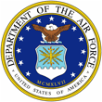 | Dr. Steven B. Davis  s | 

UNITED STATES AIR FORCE

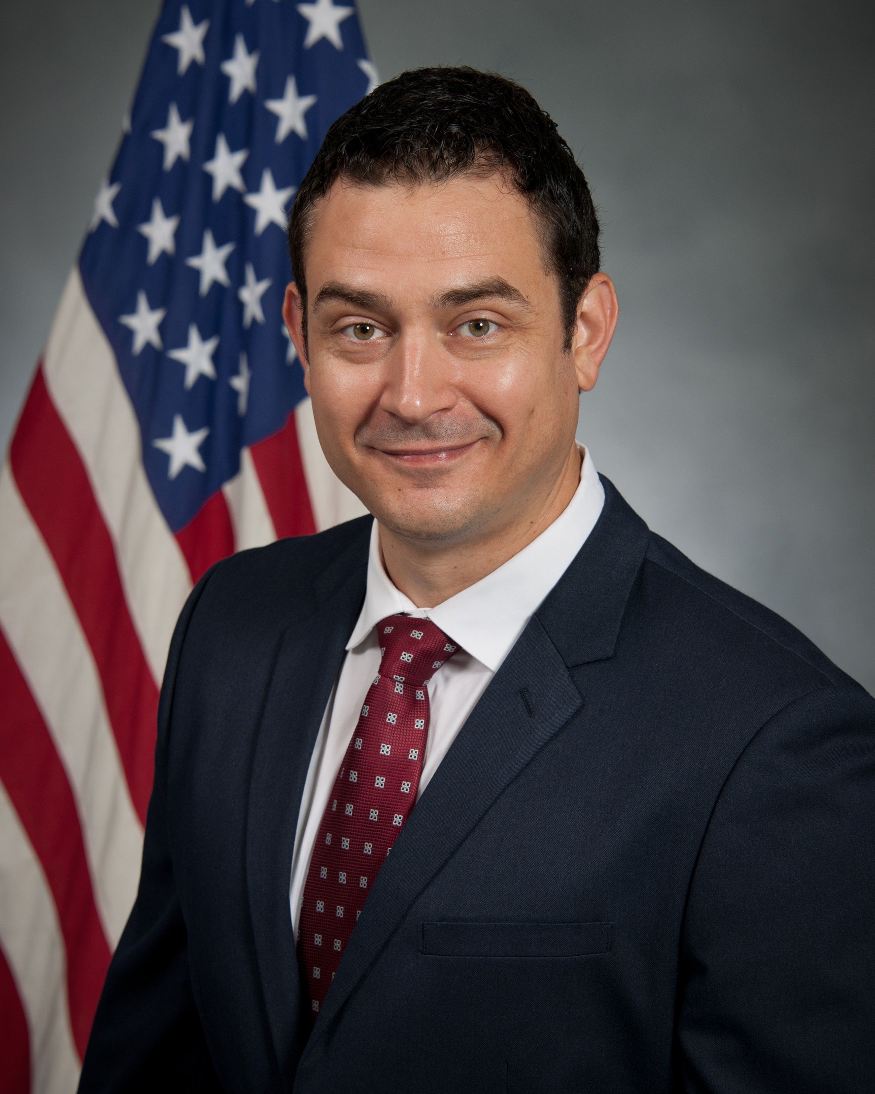
Duty Title: Assistant Professor of Leadership

Hometown: San Antonio, TX

Myers-Briggs: ENFP Primary Voice: Nurturer

Areas of Specialization: Instructional Methods and Pedagogy, Modern German History, War and Society

Favorite quote: “The art of teaching is the art of assisting discovery.” – Marc Van Dore

EDUCATION
2006 Bachelor of Arts, Sociology, Texas A&M University
2010 Master of Arts, Global History, University of Bremen, Germany
2017 Doctor of Philosophy, History, Texas A&M University

TEACHING EXPERIENCE
1. Oct. 2018–Present, Assistant Professor, Air Command and Staff College, Maxwell AFB
2. 2018, Lecturer of International Studies, Texas A&M University
3. 2016–2018, Lecturer of History, Blinn College, TX
4. 2014–2015 & 2016–2017, Lecturer of History, Texas A&M University
5. 2010–2014, Teaching Assistant in History, Texas A&M University
6. 2007–2010, Language and Culture Coach, Berlitz Institute, Stuttgart/Berlin/Bremen,
Germany

