|  |  |  |
| --- | --- | --- |
| http://www.af.mil/DesktopModules/ArticleCS/Templates/Air%20Force%20-%20Biography/bio_seal.gif | Lt Col Martha Sasnett  “Jeannie” | http://www.af.mil/DesktopModules/ArticleCS/Templates/Air%20Force%20-%20Biography/bio_flag_wings.gif |
| ***U N I T E D   S T A T E S   A I R   F O R C E*** | | |

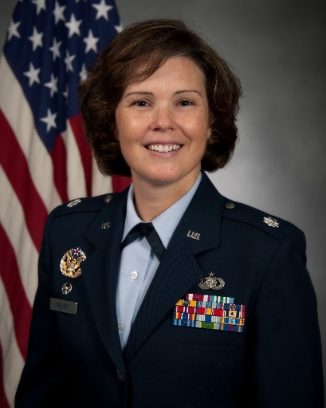

Duty Title: AU Fellow, CSAF Leadership Course

Hometown: Highlands, North Carolina

Myers-Briggs: ISFJ Primary Voice: Nurturer

Core AFSC: 38F (Force Support)

Biggest Lesson From Command: Commanders should do what only commanders can do. Trust your people and delegate. They will surprise you (in a good way)!

**EDUCATION**

1996 Bachelor of Science in Biology, Western Carolina University, Cullowhee, NC

2005 Master’s Degree in Human Relations, University of Oklahoma (Distance Learning), Spangdahlem Air Base, Germany

2007 Squadron Officer School, Maxwell AFB, AL

2011 Army Command and General Staff College, Fort Leavenworth, Kansas

**COMMAND ASSIGNMENTS**

1. Jan 2015 – Jul 2017, Commander, 42d Force Support Squadron, Maxwell Air Force Base, Alabama