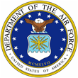 | Lt Col Justin Longmire | 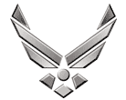

UNITED STATES AIR FORCE

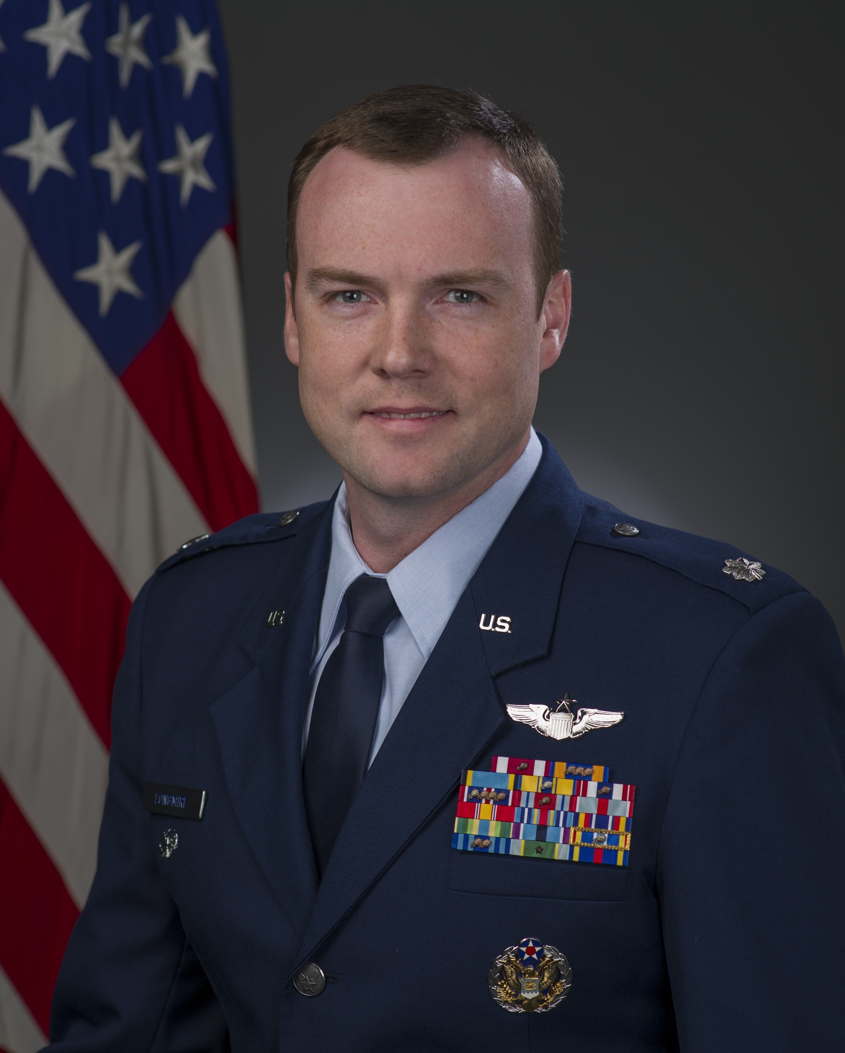

Duty Title: Course Director

Hometown: Rochester, Minnesota

Myers-Briggs: ENTJ Primary Voice: Pioneer

Core AFSC: 11M (Mobility Pilot)

Biggest Lesson From Command: Be deliberate with your time. Focus on important things like developing leaders, cultivating trust, and caring for Airmen, and you will leave it better than you found it.

EDUCATION
2001 Bachelor of Science, General Engineering, United States Air Force Academy, Colorado Springs, Colorado.
2006 Squadron Officer School, Maxwell AFB, Alabama.
2011 Master of Aviation Science, Embry Riddle Aeronautical University, Daytona Beach, Florida.
2015 Air Command and Staff College, Maxwell AFB, Alabama.
2019 Air War College, Maxwell AFB, Alabama.

COMMAND ASSIGNMENTS
1. Apr 2016-Jun 2018, Commander, 6th Air Refueling Squadron, Travis Air Force Base, California

