|  |  |  |
| --- | --- | --- |
| http://www.af.mil/DesktopModules/ArticleCS/Templates/Air%20Force%20-%20Biography/bio_seal.gif | Lt Col Duane Richardson | http://www.af.mil/DesktopModules/ArticleCS/Templates/Air%20Force%20-%20Biography/bio_flag_wings.gif |
| ***U N I T E D   S T A T E S   A I R   F O R C E*** | | |

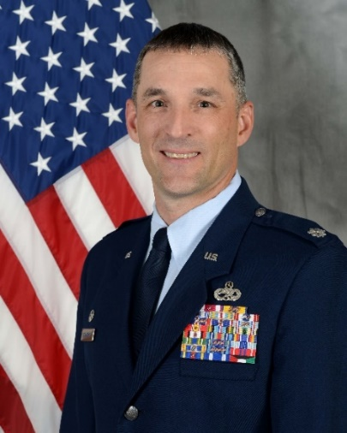

Duty Title: AU Fellow, CSAF Leadership Course

Hometown: Roseburg, Oregon

Myers-Briggs: INTP Primary Voice: Creative

Core AFSC: 21A (Aircraft Maintenance)

Biggest Lesson from Command: In EVERY decision you make, be fair and consistent. Be transparent. Don’t keep secrets, crush rumors, better yet, over share as much as possible to prevent rumors. Be true to yourself.

**EDUCATION**

1995 Associate of Applied Science, Community College of the Air Force

1999 Associate of Applied Science, Community College of the Air Force

2000 Associate of Applied Science, Embry-Riddle Aeronautical University

2000 Bachelor of Science, Embry-Riddle Aeronautical University

2003 Air and Space Basic Course, Maxwell AFB, Alabama

2006 Squadron Officers School, Maxwell AFB, Alabama

2008 Master Business Administration, Touro University, California

2011 Air Command & Staff College (non-residence), Maxwell AFB, Alabama

2015 Air Command & Staff College (in-residence), Maxwell AFB, Alabama

**COMMAND ASSIGNMENTS**

1. Jun 2012 – Jul 2014, Commander, 60th Maintenance Squadron, Travis AFB, CA

2. Jun 2015 – Jun 2017, Commander, 22d Aircraft Maintenance Squadron, McConnell AFB, KS

3. Jun 2017 – Aug 2019, Commander, 755th Aircraft Maintenance Squadron, Davis-Monthan AFB, AZ