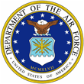 | COL Jayson A. Altieri (Ret)  s | 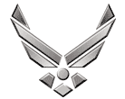

UNITED STATES AIR FORCE

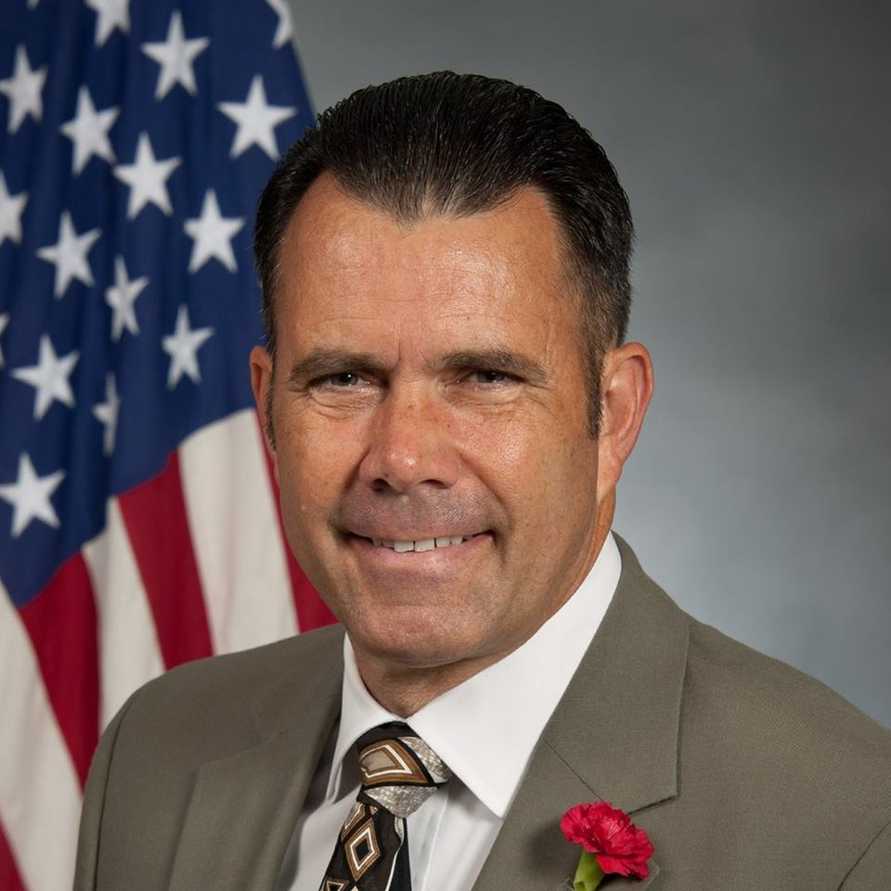
Duty Title: Assistant Professor

Hometown: Roanoke, Virginia

Myers-Briggs: ESFJ Primary Voice: Connector

Core AFSC: Command and Leadership SME

Biggest Lesson From Command: "You must inspire and lead your brave division that it may accomplish the work of a corps... our army would be invincible if it could be properly organized and officered. They will go anywhere and do anything if properly led." – Gen. R. E. Lee, CSA

EDUCATION
1986 USAF Squadron Officer School (Non-Residence), Maxwell AFB, AL
1987 USA NCO Professional Development Course, Ft. Indiantown Gap, PA
1989 Norwich University, Northfield, VT
1991 USA Aviation Officer Basic Course, Ft. Rucker, AL
1995 USA Armor and Cavalry Leaders Courses, Ft. Knox, KY
1997 USA Combined Arms Services Staff School, Ft. Leavenworth, KS
2002 USAF Air Command and Staff College, Maxwell AFB, AL
2004 USAF School of Advanced Air and Space Studies, Maxwell AFB, AL
2006 Joint Forces Staff College, Norfolk, VA
2011 USA War College, Carlisle Barrack, PA
2012 NATO Staff Officer Course, Oberammergau, GE

COMMAND/LEADERSHIP ASSIGNMENTS
Jun 1995 – Jan 1996, Commander, MOMEP Aviation Detachment, Patuca, EC
May 1997 – Sep 1999, Commander, HHC/2-82nd Aviation Battalion, Ft. Bragg, NC
Jul 2007 – Mar 2009, Commander, 2-82nd Aviation Battalion, Ft. Bragg, NC
Jul 2013 – Jul 2015, Commander, 110th Aviation Brigade, Ft. Rucker, AL
Apr 2016 – Aug 2017, Chairman, Civil Air Patrol Board of Governors, Maxwell AFB, AL

