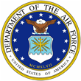
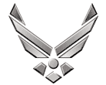
Lt Col Joe Schaefer

UNITED STATES AIR FORCE

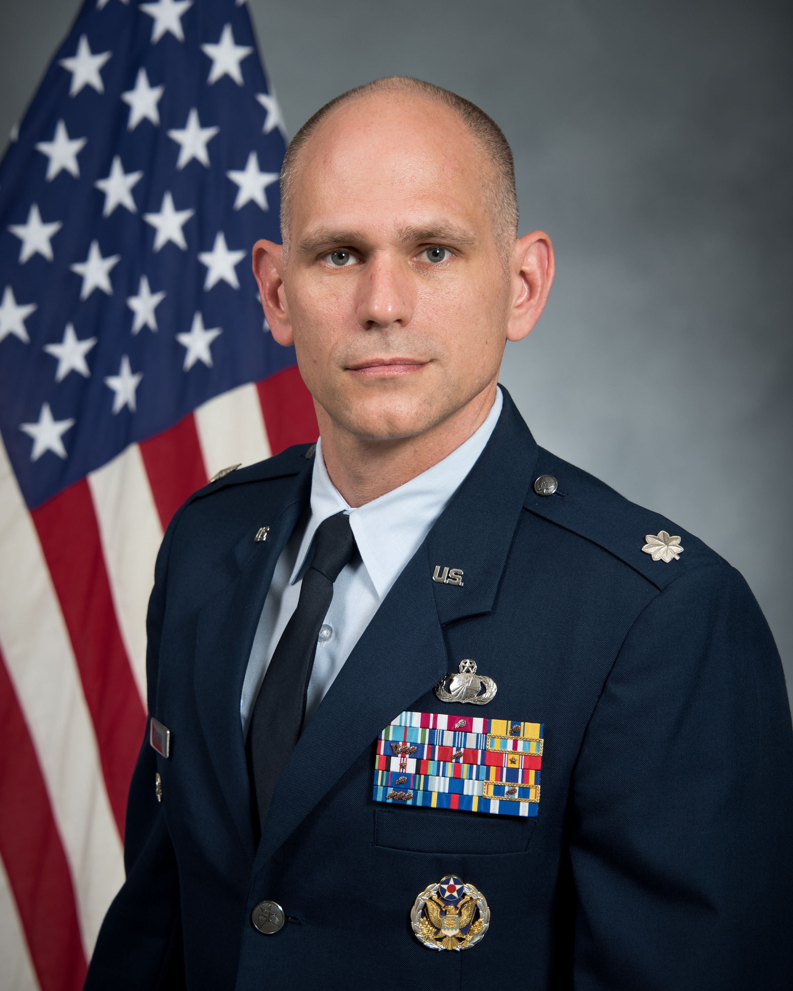
Duty Title: AU Fellow, CSAF Leadership Course

Hometown: Cleveland, OH

Myers-Briggs: INTP Primary Voice: Creative / Pioneer

Core AFSC: 65F (Comptroller)

Biggest Lesson From Command: Grow and Empower subordinate commanders and supervisors to LEAD. Allow them to make decisions and learn when to ask for your engagement. If you are doing their job, what are they learning and who is doing your job?

EDUCATION
1999 Bachelor of Science, Business Administration-Accounting, David N. Myers University, Cleveland, Ohio.
2004 Squadron Officer School, Maxwell AFB, Alabama.
2006 Master of Business Administration, Naval Postgraduate School, Monterey, California.
2010 Air Command and Staff College, Correspondence.
2016 Air War College, Correspondence.

COMMAND ASSIGNMENTS
1. May 2009 – Jun 2011, Commander, 39th Comptroller Squadron and Wing Staff Agencies, Incirlik Air Base, Turkey
2. Jul 2013 – Jun 2016, Commander, 11th Comptroller Squadron and Wing Staff Agencies, Joint Base Andrews, Maryland

