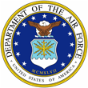 | Sandra Schiffer | 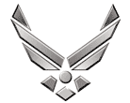

UNITED STATES AIR FORCE

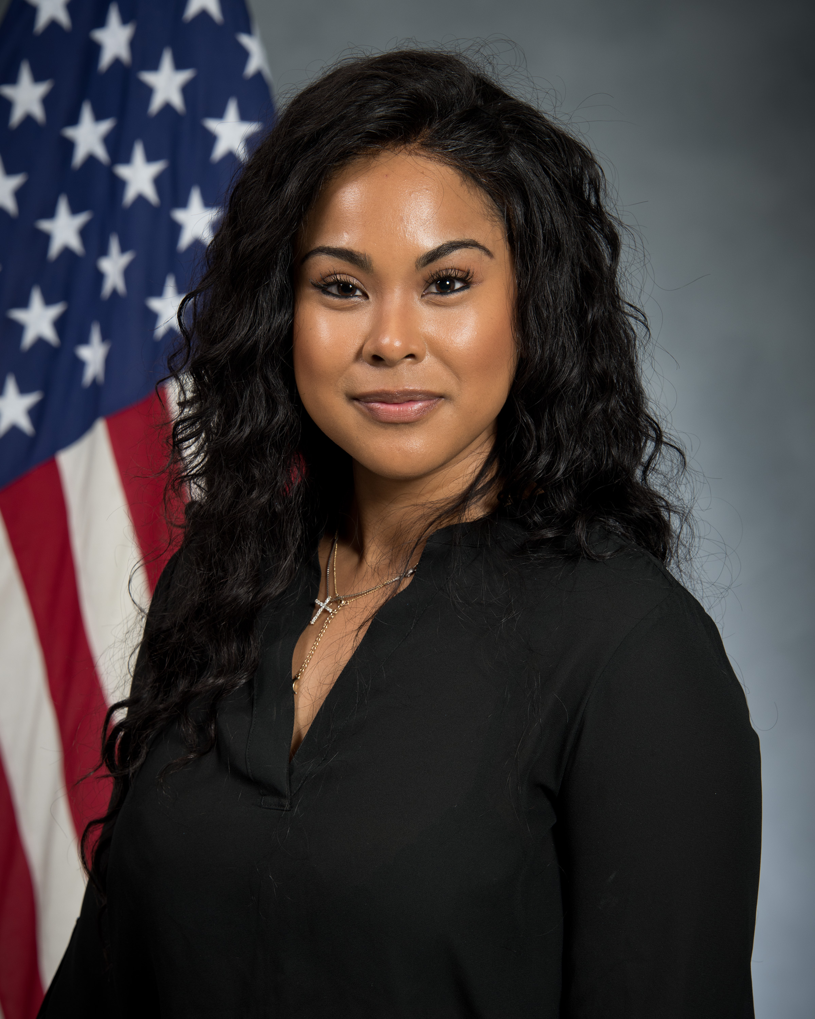
Duty Title: Education Accreditation Support, Student Manager

Hometown: Seoul, South Korea

Myers-Briggs: ISFP-A/ ISFP-T

Primary Voice: Creative & Connector

Hobbies: Traveling, snowboarding, spending time with family, going to the beach, and music

EDUCATION
2018 Master of Science in Management specializing in Interdisciplinary Studies; University of Maryland University College
2016 Bachelors of Science in Management; University of Maryland University College
2014 Bachelors of Science in Human Resource Management; University of Maryland University College

EXPERIENCE

- 2019- Present: Education Accreditation Support; Student Manager
- 2017-2019: Military Education Coordinator; University of Maryland University College, Ramstein, Germany
- 2011- 2012: Child and Youth Program Assistant; Child Development Center; Spangdahlem, Germany
- 2009- 2011: Child and Youth Program Assistant; Child Development Center; Osan, Korea

