**Personality Typology Worksheet**

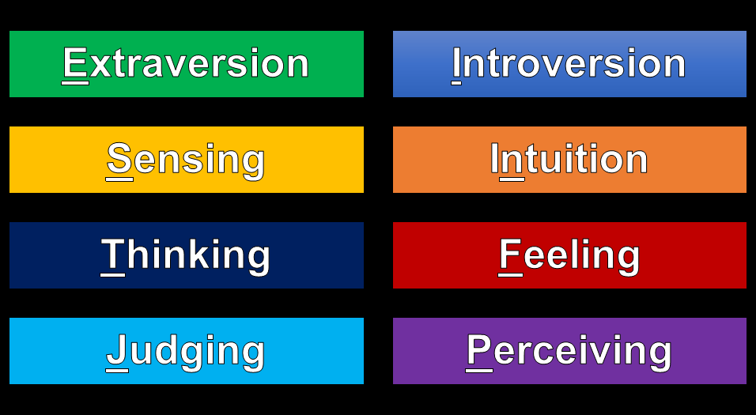

(Circle your preferences below)

*What energizes you?*

* **Extroversion (E)**:
  + I am energized by interacting with people, like face-to-face communication, very expressive, and prefer action to reflection.
* **Introversion (I)**:
  + I am energized by maintaining my privacy, like written communication, private and contained , and prefer reflection to action.

*How do you take in information?*

* **Sensing (S)**:
  + I get my information from what is real, actual, factual, concrete, and sequential. I trust my experience.
* **Intuition (N)**:
  + I get my information from patterns, meanings. I am abstract, imaginative, and like metaphors, and analogies. I trust my insight.

*How do you make decisions?*

* **Thinking (T)**:
  + I make decisions with my head. I focus on the desired outcome, objective, while preferring critique and analysis. I am firm, but fair.
* **Feeling (F)**:
  + I make decisions with my heart. I focus on how others feel, subjective, while preferring praise and understanding. I am forgiving and merciful.

*What is your orientation with the outside world?*

* **Judging (J)**:
  + I am organized, systematic, and methodical. I enjoy short and long term planning, decisive, and avoid last minute stressors.
* **Perceiving (P)**:
  + I am adaptable, curious, and open-ended. I am flexible, spontaneous, and don’t mind last-minute stressors.

**Your 4-Letter Preferences: __________________**